Stephen Gill
York University, Toronto, Canada

CAPITALISM 2009, HELSINKI

23 APRIL 2009

POLITICAL REFLECTIONS

ON THE GLOBAL ECONOMIC & FINANCIAL CRISIS

Outline

Part 1: Reflections on global capitalism & the nature of the crisis

Part 2: Finance, debt and the bail-outs

Part 3: Political alternatives – dominant and counter-hegemonic

Powerpoint will be posted on: http://stephengill.com/news.htm

Key questions

How do we characterize the crisis of global capitalism, and what are its dangers and opportunities for the progressive lefts?

What issues, principles and policies do the lefts need to consider in order to develop a new counter-hegemonic political project?

Part 1: Global crisis & capitalism 2009

What is capitalism?
Three perspectives on capitalist crises & accumulation

Market fundamentalists and “pure” neo-liberals: capitalism is an economically efficient system & crises are short-term & self-correcting. Markets should be allowed to self-regulate.

Most economists: capitalist accumulation is unstable & crises are endemic. They require macroeconomic planning & political intervention to allow for stabilization & the resumption of “balanced growth.”

The radical position: Capitalism is a system of power. It does not involve the accumulation of goods for livelihood and social well-being, but accumulation of monetary values which in turn allows for control over society & the labour of others.

Put differently the goal of capitalist accumulation has nothing to do with livelihood, it has everything to do with increasing the social power, wealth & control of the few.

Seven features of capitalism 1989-2009

Turnover time of capital accelerates, profits boom & rates of exploitation of people & nature increase.

Political power of free enterprise & the propertied fully restored, unprecedented growth of a global plutocracy.

Subordination of state forms to capital (following some socialization and nationalization of the means of production 1917-1989).

Governments promote market + privatization + workfare + cut provisions for families, education, health, leading to privatisation of risk for a majority; state guarantees (socializes) risks for big capital, e.g. huge bail-outs, subsidies.

Acceleration of extreme inequality of income, wealth & life chances.

Expropriation or dispossession of producers of their means to subsistence – parallels early capitalist dispossession, enclosure and colonization.

Capitalist markets increasingly govern food supplies, water and other basic necessities: global hunger and starvation mediated by the capitalist market in ways that resemble 19th century capitalism.

The world capitalist market increasingly determines food prices

Increased corporate control of global agriculture

Decline of local self- sufficiency & energy & fertilizer intensive export-orientation of agriculture

Produces crop monocultures & damage to the biosphere

Global futures trading e.g. in Chicago & New York markets, is linked to speculation & rapidly rising food prices in the last 10 years, especially during 2008

Market prices & rising hunger

“Almost unnoticed behind the economic crisis, a combination of lower growth, rising unemployment and falling remittances together with persistently high food prices has pushed the number of chronically hungry above 1bn for the first time”. Financial Times April 6 2009.

Since 2008 global agricultural commodities prices have fallen by 40-50 per cent, but are well above pre-crisis levels.

Domestic prices in many developing countries are close to record levels of 2008

In some African countries prices are even higher than in 2008.

Capitalism & human progress?

Reverses the decline over the past 25 years in % of chronically hungry people.

UN’s World Food Program needs $6bn (€4.5bn) in 2009 to feed the poorest, up 20 per cent from last year’s record of $5bn.

We should compare this to the gigantic costs of the financial bailouts

A broader view of the crisis

The crisis is therefore much more than a crisis of capitalist accumulation or a necessary self-correction aided by macroeconomic intervention and bailouts.

The crisis also reflects contradictions of what I call market civilization – a consumerist, privatized, energy-intensive & ecologically myopic pattern of development.

As we shall argue, it involves a de facto state of global economic emergency which presents dangers and opportunities for a variety of states and social forces – and not all of these forces are progressive – many are reactionary.

I call this a global organic crisis.

Part 2: Finance, debt & bail-outs

The financial crisis has involved 5 related sets of events

Global stock market crash & falling profits.

Frozen credit markets -- banks refuse to lend to each other or to the majority of borrowers.

A string of insolvencies that have threatened the global financial system as presently constituted.

Rapidly growing unemployment.

Socialization of the losses of capital (e.g. bank losses of $4.1 trillion in total -- IMF estimate 21 April, 2009) but not of the majority of citizens.

It is likely that the scale of the bank losses is much greater than has so far been revealed.

Immediate causes of financial crisis

In USA since early 1980s real incomes of most workers have fallen -- caused by rising exploitation of labour in USA. Workers borrow to consume & roll over debts.

Wall Street got control over US & global economic policy dating back to the Clinton Presidency; this continues under Obama.

This control allowed for “financial innovation” e.g. home loans were bundled into new tradeable financial products generating huge profits & increases in the stock prices of big banks. Banks allowed to engage in massive leveraging that was previously prohibited (borrowing against capital base by 30:1 or greater).

When US house prices fell there was a collapse in the ability of US workers to continue with their debt-funded overconsumption (US savings ratios turn negative) & to make mortgage payments.

This triggered huge losses for the banks who had borrowed at vast multiples of their capital base & this rendered them insolvent.

Global priorities: capital comes first

- EU + US + UK bailouts & fiscal stimulus = US$17 trillion.
- This is over 22 times larger than the total planned funds for the UN’s Millennium Development Goals
- MDGs seek to provide minimum & basic health & education for billions of the world’s very poorest people between now and 2020.

Crony capitalism on Wall Street

Much of the losses above have involved fraud & deception.

US $3 trillion bank bail out plans have continuity -- from US Treasury Secretary Hank Paulson (Bush) to Tim Geithner (Obama)

IHT 22 Aprl 2009: Neil Barofsky Special US Government Investigator of the Treasury/Federal Reserve bank bail out plans. His report notes that:

Plan risks jeopardizing the credibility of the recovery effort by not requiring banks to provide detailed information from banks on what they are doing with taxpayers money

It involves “significant fraud risks”, e.g. allowing investors to double up on government subsidies

Minimizes risks of investors & allows them to take big profits & leaves taxpayers with the losses

It relies on the private credit-rating agencies found at fault in the crash

US bailouts in historical perspective

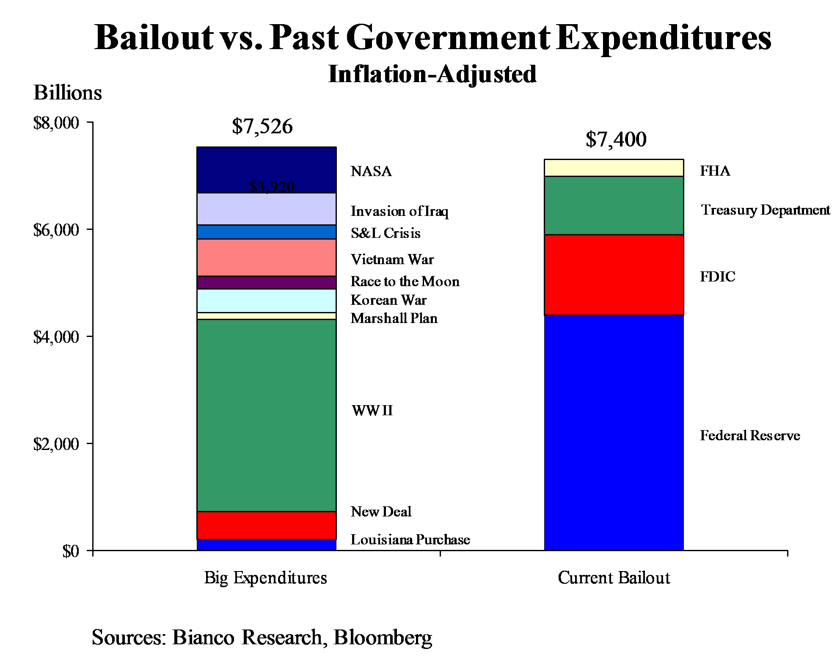

What is a trillion?

A trillion is a million million of any thing.

1 Million = 1,000,000

1 Billion = 1,000,000,000

Trillion = 1,000,000,000,000

A million seconds is 12 days

A billion seconds is 31 years.

A trillion seconds is 31,688 years

What is a trillion dollars?

One trillion dollars in $1,000 bills stacked, one on top of the other would reach upwards for 63 miles or 101.38 km

Finland’s GDP (official exchange rate) = $281.2 billion & Canada’s GDP = $1.564 trillion (2008 CIA Factbook estimates, in US dollars).

$1 trillion equals roughly 3.5 years of annual Finnish output

$17 trillion equals total Canadian output for almost 11 years.

Part 3: Future political alternatives

Capitalism 2009: 3 main sets of alternatives, each of which see a certain type of capitalism as the problem, and another type as the solution:

Bail outs will be followed by more neo-liberalism coupled with a reformulated new constitutionalism to lock in fiscal austerity – this is the position of dominant political forces

The resurgence of various forms of state capitalism.

A variety of socialist responses, including that of a number of states and social forces in Latin America premised on redistributive state capitalism

What seems to be missing is a powerful assertion of progressive left alternative perspectives based on a different understanding of political economy and society that can help articulate the need for new policies and institutions in ways that challenge the basic capitalist mode of production and distribution - I will return to this in the final part of my talk.

Three questions about the immediate political situation

How long will this state of economic emergency last?

Which key social and political forces will define it politically?

What type of global political economy will likely follow the state of emergency?

Part 3A: Future political alternatives: Dominant forces will seek a reformulated neo-liberal capitalism

After the emergency: return to a reformulated orthodoxy?

Some progressive initiatives are incorporated into the response, e.g. by Obama: appease anger over bailouts; expand healthcare insurance + “green investment.”

More pressures to privatize to pay for bail outs & pressure to reduce welfare and public service provision as a consequence of increasing deficits.

After the bail-outs: reintroduction of mechanisms to justify & lock in a return of fiscal discipline & austerity.

Reinforcement of market discipline on individuals, workers and families e.g. through growing debts (personal loss of wealth, lower incomes, reduced pensions).

IMF grows & resumes debt imperialism via donor country conditionalities and stabilization programs.

Authoritarian tendencies in the emergency?

However the bailouts & stimulus may not work, e.g. in Japan US & UK interest rates now effectively zero; huge deficits and even more government debt on the way -- who will pay the costs?

Efforts to manage the crisis – particularly if they fail – may reinforce tendencies towards a more reactionary & authoritarian capitalism as in the 1930s.

Note the effects on state apparatuses associated with the “war on terror” (the option to suspend civil liberties, impose martial law etc.) might be used against “revolts” from below.

Those countries driven to the IMF & EBRD may be subjected to a new round of austerity & disciplinary neo-liberalism; authoritarian responses may seek to contain challenges from below.

Part 3B: Future political alternatives: Counter-hegemonic forces develop a progressive alternative

Outlines for a progressive project

Prestige & legitimacy of rulers heavily damaged; complacent; caught asleep at the wheel; their claims to govern in the general interest must be contested.

E.g. deconstructing the G8 leaders’ pragmatic slogan: “no penny-pinching during the crisis, but balancing the budgets once the crisis is over” (The Economist)

This actually entails “billions for the banks, pennies for the people” (Juan Somavia ILO Director in Financial Times)

This moment repoliticizes the political economy of capitalism & mandates greater political contestation:

→ Negatively: “Who’s going to pay for this crisis?” More austerity? More taxes?

→ Positively: The gigantic sums of money now available open a vast panorama of new possibilities for human development and social progress.

How to get there from here: optimism of the will

The progressive forces – the “global lefts” (in the plural) are combining and could combine further.

I call this the post modern Prince – a global political formation in the multiple which seems to have been sidelined in addressing global crises.

Its organic intellectuals – numbering in the millions – are engaged in rethinking not only states and markets or power and production, but also the broad conditions of what feminists call social reproduction – including the ecological integrity and sustainability of the planet

This involves addressing immediate needs and longer term issues, both locally and globally

The lefts should further develop a new language of politics to address key issues – in ways that go well beyond orthodox left-wing politics. This needs to shape new policy agendas.

Pessimism of the intelligence – key obstacles to progressive proposals

There are two immediate political battles/obstacles for the progressive forces involving opportunity costs of political choices & alternatives:

Over the use of “economic emergency funds” now – which expenditures are being prioritized and which forces will benefit and why?

Over who pays and when – over what timescale?

The vast expenditures limit the future fiscal space for progressive projects.

Progressive alternatives: some principles

Progressive alternatives must be couched in terms of the production of a different kind of society with a new political imaginary & set of ethical principles:

Democracy, equality, social justice.

Economic stability & prudential regulation.

Improved social provisions grounded in better and more accountable public institutions.

Social & economic transformation consistent with ecological sustainability.

Replace the politics of fear with human security & broad based human development.

Five sites of policy contestation

Rethink the tax base and the distribution of tax burdens whilst regulating the economy effectively and prudently.

Rethink the logic of dominant lifestyles – market civilization & social and ecological sustainability – whilst preserving toleration.

Revitalize our public and collective services and infrastructure.

Address demographic shifts: ageing society

Develop policies for education & culture to help emancipate creative potentials.

Rethink the tax base and the distribution of tax burdens

The Lefts need to go beyond the slogan “we won’t pay for your crisis”

The key shift in tax regimes is away from direct taxation (e.g. income and corporate taxes) towards widespread indirect taxation (e.g. value added taxes).

Indirect taxes are very regressive -- and hit the poor hardest

Direct taxes on high earners & firms (and “the mobile”) have fallen quickly since the fall of the Berlin Wall in 1989 – e.g. Sarkozy’s “50% rule” for the very rich in France.

The rich and corporations can evade or avoid taxes through the use of tax havens & transfer pricing

The erosion of the tax base has been exacerbated by inter-state tax competition to attract investment

Rethink the logic of dominant affluent lifestyles

This involves the problem of what I call market civilization & social and ecological sustainability: Western lifestyles are energy intensive and increasingly unhealthy

The North American societies are the worst in this regard; the USA consumes the lion’s share of global resources, with its population increasingly obese.

This problem was dramatized by the first President Bush, when he refused to go to the Rio Global Environment conference in 1982, saying “our lifestyle is not negotiable”.

This lifestyle is linked to US foreign policy & giant firms who seek to control Middle Eastern and other supplies of oil and fossil fuels.

The tax and incentive regime associated with fiscal policies could be restructured to help change these lifestyles, coupled to initiatives to improve public transportation, sports and recreational facilities and to encourage healthier ways of living.

Revitalize our public and collective services and infrastructure to improve institutions of social reproduction

We have been persistently told for years that it is impossible to pay for substantial improvements in health care, education and other social facilities.

The enormous funds paying for the financial bailout indicates that this was simply a political decision.

It was only when capital was threatened with collapse that these massive funds suddenly became available.

Fiscal choices have unequal impacts on men & women at various levels in the social structure.

So we have to ask what are the opportunity costs of the bailouts – in terms of alternatives forgone to use the resources for other social purposes?

Address demographic shifts: ageing society

This concerns the fiscal and social implications, especially in Europe and Japan, of ageing populations – less pressing in the USA & much of the global South where the age structure of the population is much younger.

Compounded by the privatization of health care and of caring institutions more generally

it needs creative thinking as well as new budgeting, allowing for real social differences since the costs of this demographic transition might well far out weigh the costs of the financial bailouts.

Women tend to take the main burden of care when it is privatized and returned to the family or “private” context.

Solutions will require us to break down the dichotomy between young and old, and the distinction between so-called productive and unproductive members of the workforce and of society

Older people can make an ongoing and creative contribution well past their age of so-called retirement

Develop policies for new education and cultural dimensions of society

We need new forms of progressive culture, broad-based and critical educational systems, as well as media.

Education and media– e.g. from the primary school to the University -- subjected to a corporate-agenda.

Broad & critical purposes of education are narrowed to support a monoculture and society that in effect abstracts almost everything that is potentially profitable into saleable commodities.

E.g. Economics: alternative ways of thinking about economic systems are often removed from the curriculum; economics is equated with making capitalism function more efficiently.

Ultimately a new type of society requires a new form of politics in North & South – an inclusive, diverse, democratic. green and forward-looking political agency – the postmodern Prince.

